- See the file ‘assignment_data_series.xlsx’ to find the data series (plural!) you have been allocated (released by the end of Friday, August 7). Read up on the MARTIN model using the assigned PDFs, and check Table 1 and the appendix (of the research paper) to see how the variables in the model (corresponding to your data series) are specified (i.e. levels, logs or %) and where the data is sourced from. List the details about the series, including name, source, abbreviation. Describe in one or two sentences what each data series is about/ captures. [1 mark]
Gross national expenditure (GNE) measures the total domestic spending and real changes in inventory. GNE has a log specification, measured in real terms and sourced from the ABS (seasonally adjusted).
$${GNE}_{t}= {DFD}_{t} + V_{t} + ε_{t}$$
$${DFD}_{t} = {RC}_{t} + {ID}_{t} + {IB}_{t} + G_{t} + {OTC}_{t} + {AT}_{t} + ε_{t}$$

National household consumption expenditure (NC) is real consumption at current prices. NC, which is an adjusted RC has a log specification, measured in real term although NC is in nominal terms and sourced from the ABS (seasonally adjusted).

$${NC}_{t} ≡ {PC}_{t}×{RC}_{t}/100$$
- PC is household consumption deflator, and RC is real household consumption

- Find the most recent vintage of each data series from the relevant source up until Q1 2026 (even if more recent data is available!). This should be done using code in R using either the readabs or readrba packages.

- For each assigned data series, plot the original and updated data against each other. If the series has a clear trend in level terms (e.g. GDP or consumption) plot the quarterly % changes too. [1 mark]
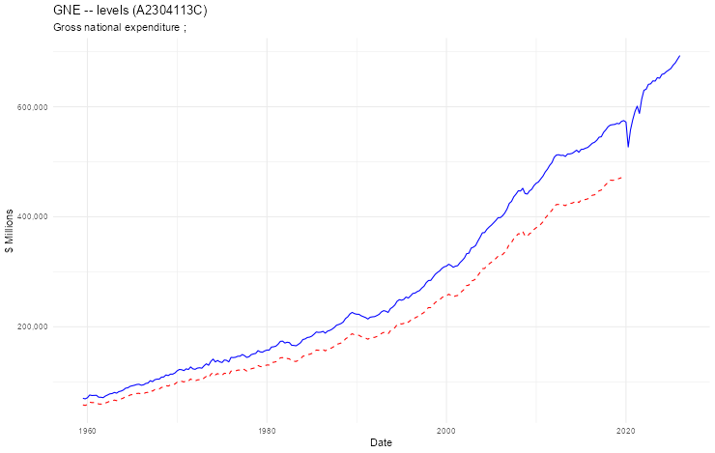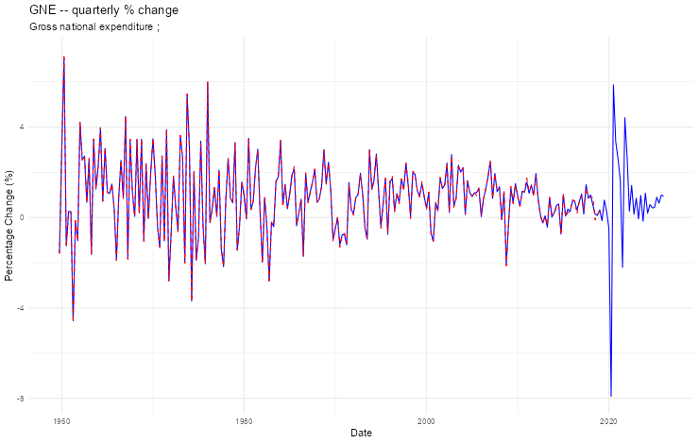

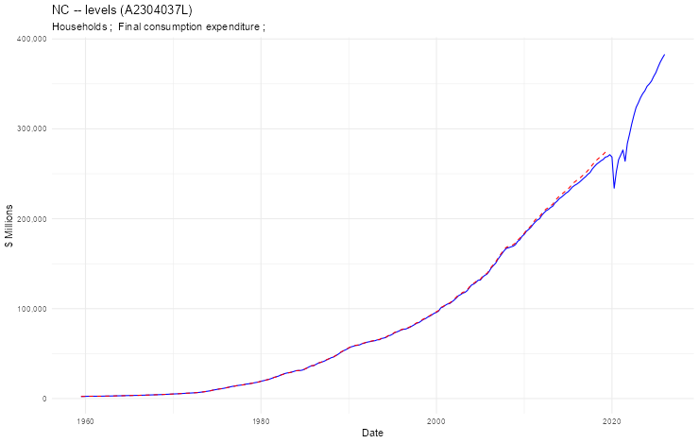
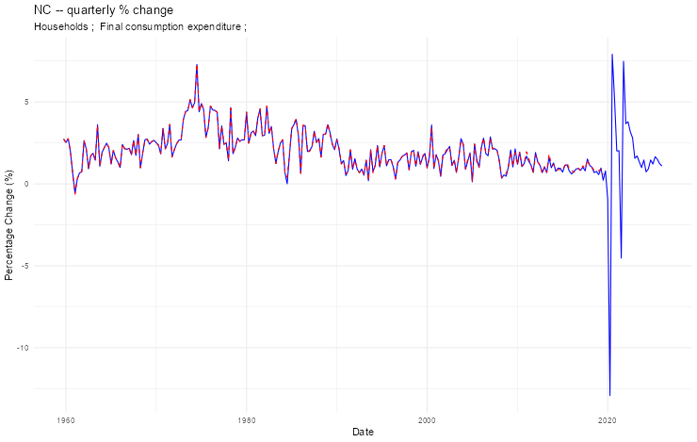

- For each assigned data series, describe any outliers in the original sample, the COVID-19 period, and any revisions made to the pre-COVID sample. [1 mark]
The GNE Levels chart is in real term (chain volume). There is a noticeable gap between the dotted red line of an older vintage compared with solid blue line of the most recent vintage. The gap between the two vintages increases over time in absolute dollar terms. There are a few noticeable outliers in the chart, the start of the 1990s was hit by high interest rates set by the RBA roughly 16-18%, the early 2000s was hit by the introduction of GST. The GFC has an impact on Australia in 2008, and the Covid-19 pandemic and subsequent lockdowns has the greatest dropped in GNE, potentially due to some businesses temporary closing if they were not an essential service.

The GNE quarterly percentage change chart shows mild revisions in the late 2010s have been made in the most recent vintage. The percentage changes are large up until the mid-1980s due to economic volatility (Australia was prone to agriculture and commodity swings). After the mid-1980s the volatility drops which can be attributed to the great moderation. Changes in inventory (V) can increase the percentage changes as It regularly changes signs. The large downward shift in 2020 is due to covid-19 and the lockdowns, which was followed by a sharp increase in period after when stimulus packages we introduced and the first lockdown ended but as the next lockdowns were enacted a decrease in GNE was recorded.

The NC Levels chart is in nominal terms. As a result of using current prices there in no reference year, the solid blue line and dotted red line overlap each other. The most recent vintage has made some revisions as the solid blue line in below the red dotted line. Covid-19 hit at the beginning of 2020 which can be seen with a sharp drop in household final consumption due to the lockdowns and household savings will have increased in its place. The sharp drop was followed by a sharp increase in household consumption, possible due to large scale stimulus packages. There are very few outliers in this chart as household consumption has consistently been increasing, part of the reason could be due to price level rising over time. 1960 to the mid-1970s show little growth in expenditure.

NC quarterly percentage change chart mild revisions in the late 2010s. Quarterly changes become increasing more tightly packed together until covid-19 hits. Apart from covid -19 and the early 1980s NC has always been in positive growth, this can be attributed to inflation as even when real consumption slumps or is stagnant the consistent increase in price levels overtime keeps nominal consumption always increasing. The 1970s show relatively high positive percentage changes in GNE due to a high inflation period in Australia before high interest rates brought the growth back down in the 1980s.

- Finally, for each assigned data series, upload the R code. The code should be a separate file which downloads the data, transforms it, and appends it to the MARTIN data file. [2 marks]

